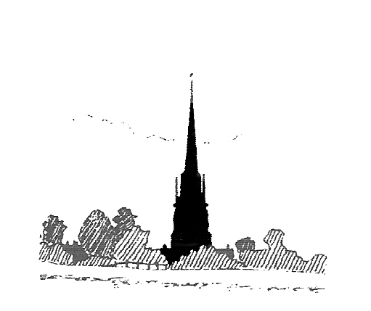
Middleton Cheney
Parish Council

Risk Assessment

Reviewed Annually

Assessment of risks that could affect the Finances or the Smooth Running of Middleton Cheney Parish Council
This brief assessment considers the implications of accidents and wanton damage to Middleton Cheney Parish Council property and, where such events may affect the finances or the smooth running of the Council what action should be taken to counter the risk.
The assessment looks at three areas:

- Damage resulting in loss of income to MCPC
- Accidents resulting in a claim against MCPC
- Loss of, or damage to MCPC assets
- Loss of Income
The major source of income comes from the Precept set annually by MCPC with a small income resulting from rental of the Parish Meeting Rooms, Cemetery and Allotment Fees, Grants, Bank interest, dividends and refund of VAT.

2. Possible Claims against the Council

Public Liability

MCPC is at risk of being asked to pay compensation to members of the public for injury, illness, or loss of or damage to material property arising in connection with the Parish Council’s activities. In particular, it is at risk of a claim arising from an accident whilst using the Parish Council’s play equipment.

Action
The Parish Council has taken out Public Liability Insurance with Aviva for cover up to £5M for any one occurrence.
In order to reduce the possibility of receiving such a claim the Parish Council’s play equipment is subject to a weekly inspection by the Litter Picker and an annual inspection by RoSPA. The recreation ground grass and the attached children’s play area are regularly cut during the summer months.
Reputable contractors are employed to undertake non-routine recreation ground maintenance to reduce the chances of possible damage to material property or injury to a member of the public. Contractors will be asked to provide Risk Assessments on the tasks they are contracted to carry out and provide a copy of their insurance

Employer’s Liability
Middleton Cheney Parish Council is at risk of being asked to pay compensation to an employee for injury or illness arising out of, and in the course of, their employment by the Parish Council.

Action
The Parish Council has taken out Employer’s Liability Insurance with Aviva for cover up to £5M for any one occurrence.

3. Loss of, or Damage to, Parish Council Assets
The Parish Council’s assets, together with their replacement value, are listed separately in the asset register.

Bus Shelter
The risk of damage to the Bus Shelter comes from serious vandalism or from vehicular impact. The Parish Council owns two of the Bus Shelters – one on Main Road and the second at the Chacombe Road opposite Stanwell Drive.
The chances of damage from vehicle collision are very low. If it were hit by a lawful driver, a claim could be made on the driver’s insurance. The shelter is a robust wooden and tile structure that makes it an unlikely target for serious vandalism.

Action
The Parish Council has looked at insuring the Bus Shelter for it’s full replacement cost, less the first £250 of any claim, with Aviva for damage by either of the above possibilities. The Council considers that the chances of a hit by an illegal driver is so remote as to not need consideration and that any vandal damage is likely to be minor or graffiti which will cost less than the insurance excess to put right.
The Parish Council has decided not to take any action.

Gates and Fences
The risk of damage to Astrop Park Play Area and Stanwell Park gates and to the fence around the children’s play equipment comes from serious vandalism at both sites or from vehicular impact at Stanwell Park. If either were hit by a lawful driver, a claim could be made on the driver’s insurance.
Minor vandalism of the fence may continue on a regular basis, breaking a small number of pales from the fence etc.
The Parish Council has looked at insuring the gates and the fence for their full replacement cost, less the first £250 of any claim, with Aviva against damage by either of the above possibilities. The Council considers that the chances of a serious hit by an illegal driver is so remote as to not need consideration and that any vandal damage is likely to be minor, costing less than the insurance excess to put right.
The Parish Council has decided not to take any action.

Play Equipment

The risk of damage to the items of play equipment comes from serious vandalism. The expensive items are generally substantial, mainly metal, structures that are likely to require powered equipment to cause significant damage. The other chance of significant damage is for parts of the wooden fence to be used to start a fire under one of the play items but in a village that has only a minor vandalism problem the chances of such action is considered to be < 1 in 40 years (most of the play items have an expected lifetime of 15-20 years). It should be noted that the play equipment is surrounded by a fence and in very close proximity to houses.

Action
The Parish Council has decided not to insure the Play Equipment but instead to continue to put aside £500 per year into a reserve fund to be used for the repair and eventual replacement of the items.

Money
At any one time the Parish Council may have relatively small sums of money or cheques in the possession of the Clerk or various Councillors. There is a small risk of such sums of money being lost or stolen.
The risk of fraud or inadvertent accounting errors are minimised by Monthly Bank Reconciliation carried out and by the requirement for all cheques to be signed by two Councillors. Both internal and external audits are carried out annually.

Action
The Council has insured with Aviva against the risk of loss or theft of relatively small sums of money. The maximum that could be claimed is up to £XXX in a Clerk’s or Councillor’s house and up to £XXXX in transit.
The Parish Council has looked at possible accidents and possible incidents of wanton damage and has taken what it believes to be appropriate action to protect its financial position and to ensure that it will be able to continue to conduct its business. It should be noted that the loss or damage to any of the assets listed in Section 3 would not disrupt the smooth running of Parish Council business.

