PARISH COUNCIL GENERAL MEETING
23/04
Venue: Parish Meeting Room
19th December 2022 19:15
Minutes

Present:
Cllr Kristian Burgess
Cllr Ruth Hoose
Cllr Alison Knight
Cllr Richard Solesbury-Timms
Cllr Kay Stevens
Cllr Nina Truman
Parish Clerk / RFO

Due to absence of Chairman Youel, Vice Chairman Burgess chaired the meeting of the full council.
22/1241 Apologies for absence
Apologies received from Cllr Youel, Cllr Allen, Cllr Jerrams Coughtrey and Cllr Washer.
On the proposal of Cllr Hoose, it was RESOLVED: to approve apologies for absence.

*22/1243 Members’ declaration of interest in items on the agenda
None declared. Item addressed out of sequence in error.

22/1242 OPEN MEETING
A representation was made on 22/1245 Land at Waters Lane. A resident read a statement regarding objections to the developers’ application to remove provision of affordable housing.
A representation was made on the following:
22/1246,7 Open Spaces. More information should be provided regarding the configuration of the green spaces, considerations made towards parking implications (cite Miller’s Way example).
22/1255 Emergency plan. Consideration of Winter provisioning. Volunteer consultation.
22/1259 Cemetery memorials. Query regarding the future enforcement of existing rules on existing graves.
Open meeting closed 19:23
22/1244 Approval of minutes of meeting 17/10/2022
On the proposition of Cllr Knight, it was RESOLVED: To approve the minutes of the meeting of Council on Monday 21st November 2022.
DRAFT

22/1245 WNS/2022/2252/MAR, Land at Waters Lane
The council discussed requirement for affordable housing to make property accessible to a younger population to balance the aging population of the village. The council discussed the developers to consider selling the site if unable to make acceptable profit and provide affordable housing as previously agreed. Statement to be drafted in co-ordination of District Councillors.

22/1246 Planning – letters, decisions and applications
Objection (as outlined in 22/1245) to be raised against WNS/2022/2252/MAR removal of affordable housing. No other comments or objections.

22/1247 S106 Agreement Thenford Road
Task & Finish group to explore further detail from developers and report to Amenities committee.

22/1248 Millers Way open space
Task & Finish group to explore further detail from developers and report to Amenities committee.
22/1249 Adoption of Budget 2023/24
A summary was provided by Cllr Hoose of the meeting of the Finance & Policy committee, identifying where considerable savings had been made and reallocated to absorb rises in costs and potential extra spends. The council agreed to make a statement as the new budget decrease is the result of a sustained effort to spend considerately in the interests of the parish.
On the proposition of Cllr Hoose, it was RESOLVED: To adopt the budget of £151,355.00 for the financial year 2023/24 as proposed by the Finance Committee.

22/1250 Approval of Precept Demand 2023/24
On the proposition of Cllr Knight, it was RESOLVED: To make a precept demand of £133,728.00, determined by the final budget adopted, for the financial year 2023/24.

22/1251 Street Lighting Project Update
Confirmation of completed and outstanding works
Motion 1: On the proposition of Cllr Hoose, it was RESOLVED: To approve in principle 50% balance payment to Lighting installation company £33,645.00, pending confirmation of outstanding works.
Motion 2: On the proposition of Cllr Truman, it was RESOLVED: To authorise the Lighting installation company to carry out additional works as per quotation 6691.

22/1252 Website upgrade - attached
A Task & Finish group, Cllrs Knight, Burgess, Truman, Allen (?) to explore potential for website upgrade.

22/1253 Maintenance works and play areas
A 3rd quote to be obtained for windows at PMR.
Local trades person to quote for bolts at play areas.
Bench – discuss with grass contractor regarding repair
Leave goal posts for now – not in immediate need of repairs, explore sleeves/guards to protect against
strimmer damage. Clerk to source information on goal area grass alternatives.

22/1254 VAS update
Data to be obtained by February meeting. Cllr Solesbury-Timms and Cllr Knight volunteered their time.

22/1255 Emergency plan
The previously established Task & Finish group to liaise and hold meeting with community, local organisations and services to create draft updated Emergency Plan c. May 2023.

22/1256 Authorisation of payments
On the proposition of Cllr Solesbury-Timms it was RESOLVED: To approve and provide dual signatory on
payments scheduled November-December 2022.
22/1257 Grant allocation protocol
Confirmation by clerk this item was included prematurely in error. Review in January as intended.

22/1258 Allotments updates, regulations and agreements
On the proposition of Cllr Solesbury-Timms it was RESOLVED: To adopt the amended Allotment rules & regulations and tenancy agreements, pending following adjustment:
- To include use of cardboard for weed-surpression, 10.1
Council to consider amendments to 5.9 and 8.5 should the council obtain larger allotments.

22/1259 Cemetery – memorials, rules & regulations
Full council to review current cemetery rules & regulations in their entirety for January meeting.

22/1260 Matters for information
The Parish Council of Middleton Cheney expressed their thanks to their employees for their work over the past year. The council greatly appreciates the initiative and continuity demonstrated by Debbie and Richard during other staff transitions and also extended gratitude to the clerk for her fulfilment of the role.

22/1261 Exclusion of press and public
It is proposed that, in accordance with Section 1 (2) of the Public Bodies (Admission to Meetings) Act 1960, the public and press are excluded from the meeting during the consideration of the item set out below on the grounds that publicity would be prejudicial to the general interest by reason of the confidential nature of the business to be transacted.

22/1262 CCTV and security contracts
Decisions made in line with discussions held during budget-setting procedures.
22/1263 Staffing protocols
Clerk to discuss procedures with small local services
22/1264 Winter provisioning
Protocols and quote considered
22/1265 Open spaces contracts
Date determined for further discussion
22/1266 Cemetery memorial
Information provided
22/1267 Next meeting 16th January 2022 – Full Council Meeting.
Signed:

Application Number | Comments due | Location | Proposal | Parish Council Comments
WNS/2022/2333/FUL | 17/01/2023 | Moor View 6 The Moors Drive Middleton Cheney OX17 2PN | Two storey rear extension with associated single storey side extension.
WNS/2022/2319/LDP | 18/01/2023 | Footpath behind Meadow Lea Astrop Road, Middleton Cheney, OX17 2PH | Certificate of Lawfulness for proposed development for information board


To consider the adoption of a Scheme of delegation.
23/10
Category: Policy | Status: Draft
Responsible: Finance & Policy Committee | Adoption minute ref:
Applicable to: Committee/ Working Group | Adoption date:
Version: 1.0 | Next review:

Middleton Cheney Parish Council
Scheme of Delegation
- Scope of the policy
  - With a few statutory exceptions, only the Full Council is able to make decisions on behalf of the corporate body, unless it makes explicit provision to delegate powers to either a committee or officer (or in some cases, another authority). These delegated powers are enshrined in the Council’s key governance documents – its Standing Orders, Financial Regulations, Committee Terms of Reference and Task & Finish Group Terms of Reference – as well as other policies. The purpose of the Scheme of Delegation is to consolidate these delegated powers into one document:

• providing a single point of reference to inform decision-making;
• ensuring that that there is no conflict between different governance documents;
• clarifying lines of accountability;
• and confirming where statutory responsibilities sit.

- What and who is covered by the policy
  - The policy comprehensively covers all aspects of the Council decision-making process, and it is therefore intended as a key reference document for all staff and councillors, particularly: the Parish Council Chairman, Committee Chairs and the Parish Clerk.
  - It should also be publicly available and published online to provide those members of the community attending Council meetings with a guide to how the Council makes decisions.

- Legal framework
  - A Scheme of Delegation is considered best practice by the National Association of Local Councils and is a requirement for Council seeking Quality Award status.
  - The Council’s statutory power to delegate its functions is laid down in Local Government Act (LGA) 1972 s101. This states that power can be delegated to a committee, sub-committee, or officer of the authority, or to another authority.
  - By virtue of the absence of any provision in s101, parish councils’ power cannot be delegated to an individual councillor. However, when acting as the chair of a meeting, a councillor has ex officio powers to regulate conduct in the meeting, as discussed below.
  - Where powers are delegated to a committee, the primary source of best practice on how they are delegated and exercised is Knowles on Local Authority Meetings (McCourt, 8th Edn, 2016), as discussed below.

- Full Council
  - The following matters are reserved to the Council for decision, notwithstanding that the appropriate committee(s) may make recommendations for the Council’s consideration:
- Approving the annual budget and setting the precept.
- Approving the annual return, and internal audit reports.
- Authorising all borrowing.
- Adopting and making any amendments to the Standing Orders, Financial Regulations, Scheme of Delegation, or Policy Framework.
- Making orders under any statutory powers.
- Making, amending, or revoking by-laws.
- Establishing committees and determining their terms of reference and membership.
- Appointing or co-opting to a committee or sub-committee of a person not a member of the Council or the committee.
- Appointing or nominating Council representatives to outside bodies.
- Creating, approving, or reviewing a neighbourhood plan.
- Declaring eligibility for the General Power of Competence.
- Appointing and dismissing the Parish Clerk.
- The decision to prosecute or defend in a court of law, save where such a prosecution is of a debtor being carried out through the small claims court.
- All other matters which must, by law, be reserved for the Full Council.
- Approving all expenditure not otherwise delegated to a committee or officers, in accordance with approved limits.

- Clerk
  - The Parish Clerk acts as the Council’s Proper Officer and Responsible Finance Officer (under s.151 LGA 1972), and is responsible for all statutory duties imposed upon these two offices. These include:
  - Receiving declarations of acceptance of office.
  - Retaining a copy of every councillor’s register of interests.
  - Signing notices or other documents on behalf of the Council (other than legal and financial documents requiring the signatures of members of the Council).
  - Signing summonses to attend meetings of the Council.
  - Keeping a proper record for all meetings.
  - Ensuring the Council meets its obligations in accordance with the Accounts and Audit Regulations in force at the time.
  - The proper administration of the Council’s financial affairs, including ensuring the Council has an adequate and effective system of internal control.
  - Producing all financial management information, including, completing the annual financial statements of the Council.

  - In addition, the Clerk has the delegated authority to undertake the following matters on behalf of the Council:
  - The day-to-day administration of services, together with routine inspection and control of assets and procedures.
  - Managing all Council staff, directly or indirectly, including the recruitment to any existing post on a like-for-like basis.
  - Authorising any expenditure delegated within approved limits.
  - Postponing a meeting or calling an additional meeting of the Council or any committee, as necessary, in consultation with the Chair of the Council or appropriate committee.
  - Responding to any correspondence requiring or requesting information, or relating to previous decision of the Council, but not correspondence requiring an opinion to be taken by the Council or its committees.
  - Managing the provision of Council services, buildings, land, and resources, including the temporary closure of any such facilities, as may be required.
  - Dealing with dispensation requests from members, under the Code of Conduct.
  - Dealing with all day-to-day staffing and disciplinary matters in line with the disciplinary procedure.
  - Prosecuting a debtor, where such prosecution is through the small claims process, or approving the write off of any debt up to the value laid down within approved limits.
  - Authorising the issue of all official Council press releases, and editorial control of the Council’s website and social media content.
  - Applying for any grants and other funding on the Council’s behalf.
  - Disposing of or selling any equipment or consumables, save where the estimated value of any one item of tangible movable property exceeds any amount laid down.
  - Renewing any existing leasing or licencing agreements, save where the estimated value exceeds any amount laid down, or where the lease term exceeds one year.
  - Agreeing any rent or licence fee increase in accordance with the terms of the agreement, save where any increase exceeds the lesser of 3% above RPI or £5,000. This item notwithstanding, every lease shall be reviewed by the relevant committee no less than every five years.
  - Entering into negotiations on any matter on behalf of the Council, it being understood that the Clerk shall not be authorized to confirm any agreement without the consent of the Council or relevant committee.
  - Dealing with such matters as specifically delegated by the Council or committee.
  - Applying the Council’s common seal to a deed required by law, in the presence of two members of the Council.
  - Delegating duties to a subordinate officer, save where such duties are required to be carried out directly by the Proper Officer or Responsible Finance Officer, by statute, or Council direction.
  - All delegation of duties is at the discretion of the Council, save where such delegation is required by statute.

- Council Chairman
  - No matter may be delegated to the Council Chairman except for the following:
  - Convening an extraordinary meeting of the Full Council.
  - Receiving the resignation of any member.
  - When attending a Full Council meeting, the powers granted to a chair of a meeting.
  - Attending a civic function as a representative of the Council, it being understood that the contents of any speeches must not purport to being the view of the Council unless previously agreed.

- Chair of a meeting
  - When a councillor acts in the role of the chair of a meeting, they shall have the power to:
  - Convene an extraordinary meeting of the relevant Council or committee.
  - Direct the order of speaking.
  - Direct any response to a question posed during public participation.
  - Permit an individual to be seated whilst speaking.
  - Suspend or close a meeting, where a resolution has been made to that effect, or where the meeting is subject to disorderly conduct, in accordance with the Council’s Standing Orders
  - In the case of an equality of votes on any matter, exercise a casting vote.
  - Determine the rules of debate, in accordance with the Council’s Standing Orders.
  - Determine a point of order.
  - Put a motion to the vote.
  - Sign the minutes of a previous meeting, once confirmed by a resolution as an accurate record.
  - Move that a person be silenced or excluded from the meeting for disorderly conduct.

- Councillors
  - No matter may be delegated to an individual councillor, except that:
  - Two councillors may convene an extraordinary meeting of the Council, should the Chair refuse to do so.
  - The Chair and HR Committee Chair shall act informally as line managers for the Clerk.
  - Matters may be delegated to an officer to determine in consultation with one or more councillors, it being understood that the officer shall not overrule any reasonable request of that member(s), but that the officer’s decision shall be final.
  - A councillor may arrange or attend a meeting regarding Council business, it being understood that any representations made by the councillor are in their personal capacity, and may not represent the views of the Council.
  - A councillor may assist in discharging any Council policy or procedure, if it is expressly permitted in the policy, or if prior approval from the relevant person has been obtained.
  - No councillor may issue an instruction to an officer, but may highlight any issue that they believe requires the attention of the Council. Any issue regarding staff performance may only be raised with the Parish Clerk or through the appropriate committee.

- Committees
  - Under the Local Government Act 1972 s101, the Council may appoint committees to undertake any of its functions not described in item 1.1 above.

  - Best practice on the constitution of committees’ states that:

“there should be no more standing committees than are necessary, the membership of the committees should be small, their terms of reference should be clearly specified, and their relationship to the rest of the decision-making structure clearly defined. Each committee should be concerned with matters that can only be dealt with at member level, i.e. there should ordinarily be no involvement in matters of day-to-day administration and operation business that is properly the responsibility of officers.” (McCourt, 2016, p.211)

  - A committee may not comprise fewer than three voting members (McCourt, 2016, p.226).

  - Where any member is deemed an ex officio member of any committee, they are a full member of that committee, unless expressly stated otherwise (McCourt, p.224).

  - Any committee established for the controlling of the Council’s finances, must be solely comprised of councillors (Local Government Act 1972, s.102).

  - On the terms of reference: “[they] should cover the whole of the council’s area of operations, but should be so drawn that one set of terms does not overlap another… most authorities provide for the terms of reference of an appropriate committee to include responsibility for ‘any matter not delegate to… any other… committee.’” (McCourt, 2016, p.227)

  - LGA 1972 s.101(2) states that unless otherwise stated, where a power has been delegated to a committee, that committee can arrange for a sub-committee or officer to discharge those powers.

  - The terms of reference must also not contradict any provision made in the Council’s Standing Orders or Financial Regulations, which shall take precedence where there is any conflict.

  - ‘Standing committees’ is a term used to simply to refer to committees set up ‘year after year’ (McCourt, 2016, p.212) and they have no statutory or special position of authority.

  - Specific terms of reference are available for each of the Council’s four standing committees: Human Resources; Finance and Policy; Planning and Highways; and Amenities.

  - There is concern that where contentious issues are raised, there should be a mechanism for these to be referred to the Full Council. Therefore, it is accepted within all committee terms of reference, that where an item is delegated to the committee, but a resolution is not passed by at least a two-thirds majority, the item is referred to the Full Council with a recommendation agreed upon by a simple majority.

Document History
Version | Author | Date | Changes | Status | Minute ref
1.0 | A Youel | 20-12-2022 |  | Draft

23/11
To consider signing the Civility and Respect Pledge (NALC, SLCC, OVW).
CIVILITY AND RESPECT PROJECT
Throughout the sector, there are growing concerns about the impact bullying, harassment, and intimidation are having on local (parish and town) councils, councillors, clerks and council staff and the resulting effectiveness of local councils.
The National Association of Local Councils (NALC), One Voice Wales, the Society of Local Council Clerks (SLCC) and county associations have responded to this by setting up a Civility and Respect Working Group to oversee the Civility and Respect Project.
NALC, SLCC, and OVW believe now is the time to put civility and respect at the top of the agenda and start a culture change for the local council sector.
The Civility and Respect Pledge is being introduced because there is no place for bullying, harassment and intimidation within our sector. The pledge is easy for councils to sign up for and it will enable councils to demonstrate that they are committed to standing up to poor behaviour across our sector and to driving through positive changes which support civil and respectful conduct.
We invite all councils to take the Civility and Respect Pledge.

The pledge
By signing the Pledge, your council is agreeing that the council will treat councillors, clerks, employees, members of the public, and representatives of partner organisations and volunteers with civility and respect in their roles and that it:
• Has put in place a training programme for councillors and staff
• Has signed up to the Code of Conduct for councillors
• Has good governance arrangements in place including staff contracts and a dignity at work policy
• Will seek professional help at the early stages should civility and respect issues arise
• Will commit to calling out bullying and harassment if and when it happens
• Will continue to learn from best practices in the sector and aspire to be a role model/champion council through for example the local Local Council Award Scheme
• Supports the continued lobbying for change in legislation to support the Civility and Respect Pledge including sanctions for elected members where appropriate
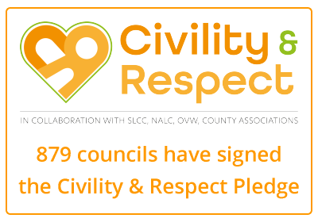
Sealed Knot 360 anniversary event
To consider hosting and funding 360 anniversary event.
23/13

Middleton Cheney Event 3rd & 4th of June 2023 Draft Budget
William Gordon’s Regiment of Foote
Draft Budget figures for a two day mini muster event with an upper limit of 200 sealed knot attendees.
1/ SK camping amenities provision 900
1/ SK “Living History” camp provision 350
1/ SK Performance activities 1200
4/ SK Educational visits 200
Total £2650
Example Schedule of Events each day:
10.00 SK Living history camp opens to public
10.30 to 11.30 Reenactment cameo’s and drill displays
12.00 to 12.30 Full Parade
12.30 Memorial Ceremony with salute
13.00 Battlefield Trust Plaque unveiling and dedication (Dignitaries and SK big wigs)
14.30 Pre-Performance Muster for Battle
15.00 Battle Performance
15.40 Closing Parade of Armies
16.30 Living history closes to public
Timings and events will vary e.g the memorial ceremony and plaque unveiling will happen on either the Saturday or Sunday. On the Sunday a Church parade can be organised if not conflicting with other events
Notes and assumptions:
1/ SK camping amenities including: Fire safety equipment, toilet facilities, waste disposal arrangements, camp security arrangements. Amenities will cover camping from Friday 2nd evening to Monday 5th morning.
2/ SK living history camp costs includes: fire safety equipment, waste disposal arrangements, camp security arrangements,
3/ SK Performance Activities including: Black Powder purchase/ supply and distribution, Medical Cover, Public Liability Insurance, Performance security, PA system, Performance consumables.
4/ SK Education Visits includes: 2 visits to local groups e.g. Youth Group Evening or Senior Group Evening
Assumptions: (MCPC here refers to Middleton Cheney Parish Council)
a/ MCPC will ensure appropriate space for modern camping, living history camping and a performance area as discussed.
b/ MCPC will ensure adequate wood supply for the living history camp fires.
c/ MCPC will ensure adequate potable (drinking) water supply to both modern camping areas and the living history camp. These can be in the form of temporary standpipe outlets, otherwise provision for a drinking water bowser will need to be made at additional cost. (Currently no provision has been made under the draft budget above)
d/ MCPC will ensure adequate toilet facilities are provided at the Performance and other areas for the publics use.

King’s Coronation village events
23/14
To receive updates form the assigned Task and Finish group regarding organisational plans and residents’ opinion.
To consider Parish Council role in facilitating events.

26 village organisations and business operating in the village have been identified and approached.
Responses have been received from 21 of the 26 identified.
Some organisations have confirmed they have no plans, others are meeting this month and will discuss Coronation plans then.
From conversations with organisations and businesses, there has been some interest in the Parish Council advertising a cohesive schedule of events.
Public interaction on Facebook yielded 210 responses, when asked what the village would like to see in the village to mark the Coronation:
43% were interested in a village fete.
36% were interested in a music festival.

23/15 Purchase and use of a manual gritter
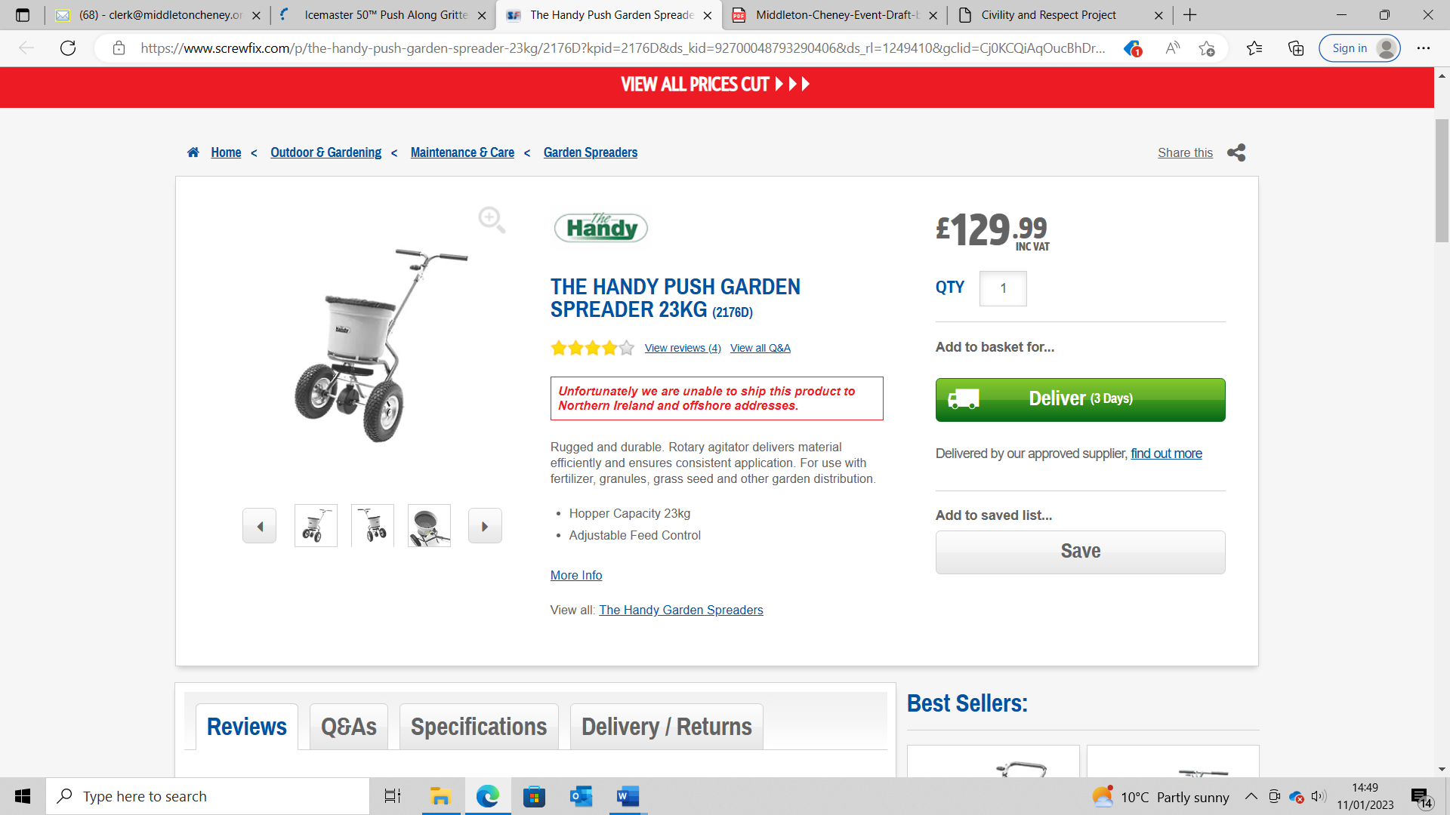
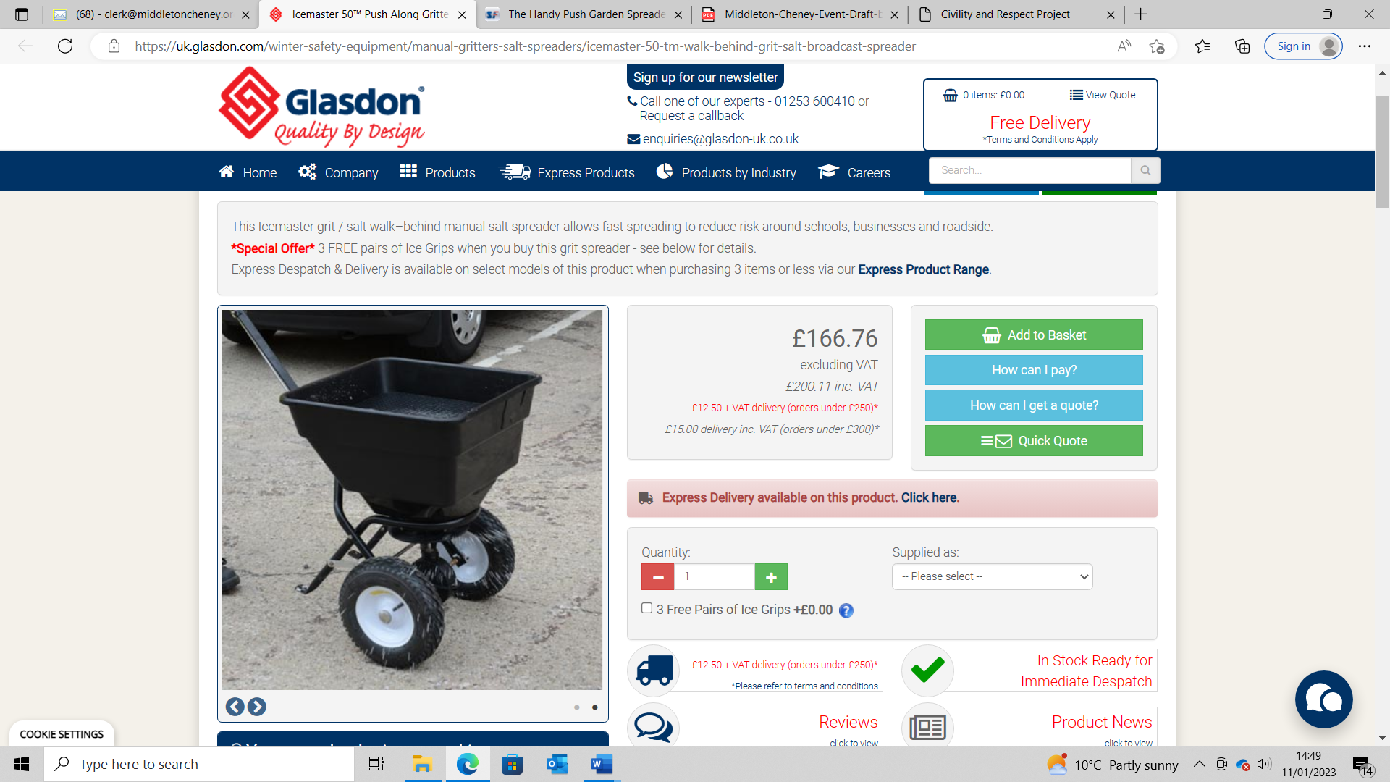
To consider the purchase of a push-along gritter and meeting safety regulations on its use.
Slips and trips - Icy conditions and winter weather (hse.gov.uk)

