PARISH COUNCIL GENERAL MEETING
Venue: Parish Meeting Room
17th July 2023, 7:15pm
MINUTES

Present:
Chairman Alan Youel
Cllr Mark Allen
Cllr Ruth Hoose
Cllr Richard Solesbury-Timms
Cllr Nigel Mills
23/181 Apologies for absence
Apologies received from Cllr Truman, Cllr Washer, Cllr Jerrams Coughtrey and Cllr Burgess and early departure from Cllr Solesbury-Timms
On the proposition of Cllr Allen it was RESOLVED: to approve apologies for absence.

23/182 OPEN MEETING
Resident: Minutes of meeting, resident’s representation on item 23/160 “encourage graffiti from the school” and “won’t quote if other companies are being considered”. Resident complained minutes were short and slightly misrepresentative of the resident’s comments regarding graffiti projects and not quoting as part of Council requirements to seek and consider 3 quotes.
23/193 Remembrance day. Why is a traffic management company being used? Can council authorise training for up to 6 people.
Open meeting closed: 19:19pm
23/183 Members’ declaration of interest in items on the agenda
None

23/184 Approval of minutes of meeting 19/06/2023, 28/06/2023
On the proposition of Cllr Hoose it was RESOLVED: to approve the minutes of meeting 19th and 28th June 2023, pending wording change to open meeting “A resident raised the issue of graffiti. Would not be a third quote.” And 23/165 Some councillors “expressed” a preference.

23/185 Planning – letters, decisions and applications – attached
Pinfold cottage: Design and access statement to be requested.
17 Meadow drive: No comments.
2 Waters Lane: No comments.
Land at waters lane: No comments.
23/186 Reports from Ward Councillors
Cllr Herring looking into “Lexton Wall”.
Cllr Solesbury-Timms Glovers Lane derelict building, investigation is ongoing with WNC. Warkworth Rd verges flagged with Highways. Highways looking at significant pothole machinery investment.
23/187 ICC report
On the proposition of the Chairman it was RESOLVED: to minute receipt of ICC report and actions.

23/188 Receipt of Cemetery at Arrow Close report.
On the proposition of the Chairman it was RESOLVED: To receive the report of records situation of the cemetery at Arrow Close. Items identified in section 9.1 to be investigated between Amenities / Finance and Policy committee. Review of progress of corrections in 6 months.
DRAFT

23/189 Review of charges, Cemetery at Arrow Close.
On the proposition of Cllr Solebury-Timms it was RESOLVED: approve reviewed charges for the cemetery at Arrow Close.

Cllr Solesbury-Timms requested this item 23/193 to be discussed here.
23/193 Remembrance events
On the proposition of Cllr Solesbury-Timms it was RESOLVED: to secure services of Pipe Band at £250.00
Better detailed plan to be requested from traffic management providers to supplement quotes. Size of crew, covering rolling road closure, type of barriers used, what will staff do during closure. Cllr Solesbury-Timms to contact service providers.

23/190 Business Continuity plan
On the proposition of Cllr Hoose it was RESOLVED: To approve the Business Continuity plan.

23/191 Village Emergency plan
On the proposition of Cllr Hoose it was RESOLVED: approve an updated Village Emergency Plan.
23/192 Civility and respect pledge
On the proposition of Cllr Allen it was RESOLVED: To adopt the Dignity at Work policy.
On the proposition of Chairman it was RESOLVED: To sign the Civility and Respect pledge.

23/194 Village maintenance
On the proposition of Chairman it was RESOLVED: to accept a series of quotes for maintenance works to play areas from Shield Maintenance Ltd (excluding fence).

23/195 Budget report
Councillors noted explanations of “overspends”.
On the proposition of the Chairman it was RESOLVED: to minute the receipt of the report.

23/196 Authorisation of Payments
On the proposition of Cllr Allen it was RESOLVED: to approve schedule of payments June – July 2023.

23/197 Reallocation of delegated responsibilities
To refer to HR Committee to clarify how it supports the Clerk in their fulfilment of staff management, HR members to meet informally before next meeting to be able to refer to next agenda. Regular scheduled meetings for the committee.
DRAFT
23/198 Exclusion of press and public
On the proposition of the Chairman it was RESOLVED: that, in accordance with Section 1 (2) of the Public Bodies (Admission to Meetings) Act 1960, the public and press were excluded from the meeting during the consideration of the item set out below on the grounds that publicity would be prejudicial to the general interest by reason of the confidential nature of the business to be transacted.

23/199 Representations to resolution processes
Nominated individuals provided updates regarding resolution processes.

End of exclusion of press and public.

23/200 Matters for information
None

23/201 Next meeting 21st August 2023 – Full Council Meeting.
Meeting closed 22:13
Signed: Clerk / RFO to Middleton Cheney Parish Council.

Finance and Policy Committee meeting
Venue: Parish Meeting Room
25th July 2023, 7:00pm

Present: Cllr Alan Youel
Cllr Mark Allen

Cllr Ruth Hoose
Cllr Nigel Mills
1. Election of Chair of the Finance and Policy Committee
On the proposition of Cllr Youel and seconded by Cllr Hoose it was RESOLVED: to elect Cllr Allen as Chair of the Finance and Policy Committee.
2. Apologies for absence:
No apologies received.
3. Declarations of interest.
None
DRAFT
4. Review of expenditure against the budget
Recently reviewed at recent Full Council Meeting week prior, no significant changes in that time. To be reviewed again quarterly to inform budget-setting and precept.
5. Discussion of actions for improving governance
Comments / response to Internal Auditor report items.
A): Now in hand following recruitment of Clerk / RFO
B): ICC previously not consistently delivered, refer back to in appropriate agenda item (10).
D): Earmarked reserves to be reviewed in this meeting (8).
J): Now in hand following recruitment of Clerk / RFO
M): Minor clerical error.
N): Information was being moved to another location on the website, consider timing of website changes.
Revisit the AIAR and Section 1 on quarterly basis.
6. Plan for review of policies
Monthly meetings to bring documents up to speed. Committee to work alphabetically through list prioritising Statutory requirements, aiming for 6 documents/policies to review per meeting.
Asbestos – Cllr Mills.
CCTV – Cllr. Allen / Cllr. Youel to locate approved document.
Certificate of waste disposal – Clerk to confirm with Shield.
COSHH (Control of substances hazardous to health) – Cllr. Youel.
Controller documentation (Article 30 GDPR) – Cllr. Allen.
Data Breach Log – Cllr. Allen.
Disabled Access Audit – Cllr Hoose.
7. Schedule of meetings for the coming financial year
First Wednesday of the month starting from September.
8. Earmarked reserves
Discussion of obsolete / redundant reserves (Preschool, Library, Unitary and NCC Financials, MCPIT, Lighting costs)
A proposed set of earmarked reserves to take to full council to in August to be prepared by Cllr. Youel.
9. Barclays mandate
On the proposition of Cllr Youel it was RESOLVED: to recommend to full council to replace two of the signatories to improve availability for banking authorisation.
10. ICC monitors
On the proposition of the Chair it was RESOLVED: to elect Cllr. Hoose as an additional ICC monitor.
11. Any other business:
Age Concern contact– to be included on next agenda.
DRAFT
Meeting closed 20:52
Next committee meeting 6th September 2023
Minuted by Clerk / RFO to Middleton Cheney Parish Council.

Application Number  23/207 | Comments due | Location | Proposal | Parish Council Comments
Applications Determined
WNS/2022/1231/FUL | STATUS: APPROVED | Land between B4525 and Chacombe Road Middleton Cheney | Partially seal existing farm access with hedgerow and install pedestrian access gate to Chacombe Road, Form new access off Chacombe Road Werving farm and proposed dog park, enclosure and parking. Dog park 50m x 160m. Moveable weather shelter and store.
2023/5639/LDP | STATUS:  APPROVED | 2 Waters Lane Middleton Cheney West Northamptonshire OX17 2NA | Certificate of Lawfulness for proposed development for alterations to change garage to a habitable room
2023/5739/COND | No Observations | Pinfold Cottage 66 Main Road Middleton Cheney OX17 2LT | Condition 3 of WNS/2022/1843/LBC [Programme of Archaeological Work ] Application for approval of details submitted pursuant to Condition 3 of planning permission WNS/2022/1843/LBC [Vehicle entrance, internal & external alterations - see Description of works on Design & Access Statement]
Applications Received
2023/5941/FULL |  | 8 Washle Drive Middleton Cheney West Northamptonshire OX17 2PX | Proposed Two Storey Side Part Front Extension with Associated Internal and External works.
2023/6014/LBC |  | 45 Main Road Middleton Cheney West Northamptonshire OX17 2ND | Replacement external signage & lighting
2023/6025/ADV |  | New Inn 45 Main Road, Middleton Cheney, OX17 2ND | Replacement Hanging Sign, Fascia's and House Name Letters.
2023/6080/LBC |  | Pinfold Cottage 66 Main Road Middleton Cheney Northamptonshire OX17 2LT | Listed Building Consent application for replacement of selected existing windows
2023/6081/FULL |  | 81 Bull Baulk Middleton Cheney West Northamptonshire OX17 2SP | First floor rear extension and related works.
2023/6009/COND |  | Pinfold Cottage 66 Main Road Middleton Cheney OX17 2LT | Condition 9 of WNS/2022/1843/LBC [Window Design] Application for approval of details submitted pursuant to Condition 9 of Planning Permission WNS/2022/1843/LBC [Vehicle entrance, internal & external alterations - see Description of works on Design & Access Statement]
2023/6243/FULL |  | 17 Horton Close Middleton Cheney Northamptonshire OX17 2LQ | Single storey rear extension
2023/6290/TCA |  | 2 Rectory Lane, Middleton Cheney, OX17 2NZ | T1 - Previously reduced ivy clad Cedar - Section fell to ground level. T2 - Spruce - reduce height by 2.5m and shape.
2023/6339/NMA |  | 10 Royal Oak Lane Middleton Cheney West Northamptonshire OX17 2LX | Non-material amendment to WNS/2022/1832/FUL New single-story rear and side extension with hipped roof. Replacement of existing single story flat roof side extension with replacement single story hipped roof side extension to reduce in size of side extension to north elevation, removal of one combination roof window in south elevation. Additional roof window to front elevation, additional roof window to rear elevation,
2023/6243/FULL |  | 17 Horton Close Middleton Cheney Northamptonshire OX17 2LQ | Single storey rear extension

As you will be aware, the LGBCE (Local Government Boundary Commission for England) have been conducting a ward boundary review for West Northamptonshire Council.
23/209 Boundaries Commission CGR

These changes will impact on some parish councils whose boundaries, as a result of the review, will no longer align with the wards. If the parish boundary is not aligned with the council ward, this may result in the need for parish wards to be created to enable the election to be conducted in areas which fall outside the council ward boundary. This can lead to additional expenses for parishes in the conduct of elections.

Community Governance Review
To meet this challenge, West Northamptonshire Council is preparing a Community Governance Review, allowing Town and Parish Councils an opportunity to put forward proposals to change your boundaries and the number of members. It also allows for the possibility of merging with an adjacent parish or parish meeting.
Any changes necessary to ensure alignment between parish boundaries and council wards will need to be carried out in the year immediately following the final decision about the Council’s ward boundaries. This is because the next ordinary election for both the Council and parishes will take place in May 2025.

Submitting your views
If your Town or Parish Council would like to form part of the Community Governance Review, we would like to hear from you. We are also keen to hear the views of residents.

In order to be a part of the Community Governance Review, you must email your views to electoralservices@westnorthants.gov.uk no later than 18 August 2023
Please consider the following in submitting your views:
- Are there any parish meetings which should be incorporated into a parish council?
- Should any parish councils be merged with another parish council or parish meeting?
- Are any changes required to the existing boundaries of a parish to better reflect local communities? (this may be particularly relevant in areas where there has been housing development for instance.)
- Are there any parish councils that should be renamed to better reflect the communities they represent?
What is not within the scope of this review:
- The ward boundaries of West Northamptonshire Council
- Parliamentary boundaries
- The conduct or membership of individual parish councils or meetings.
National Guidance on the Community Governance Review process can be found here
The review process
We will start preparing for the Community Governance Review as soon as West Northamptonshire Council’s new ward boundaries are confirmed, and will draw up proposed terms of reference for the review. We are also happy to receive requests for those who know they want a change to the parish boundary between now and until 18 August, to enable us to properly consider their request to be included within the review.
The proposed timetable is as follows:
- 1 August 2023: Final decision of the Boundary Review
- 18 August 2023: Deadline for requests from Parishes for Community Governance Reviews
- 28 September 2023: Report to Council to commence Community Governance Review
- 28 September 2024: The Community Governance Review must be completed by this date. The review will require West Northamptonshire Council to draw up proposals as to how the boundaries will be redrawn and then to carry out public consultation in relation to those proposals before a final decision is reached. A formal decision is made by full Council to amend the boundaries.
- By December 2024: Polling Station Review for new wards and parishes
- January - May 2025: 2025 Election delivery underway

Visit our Consultation Hub for more information about the Community Governance Review in West Northamptonshire and how you can get involved.
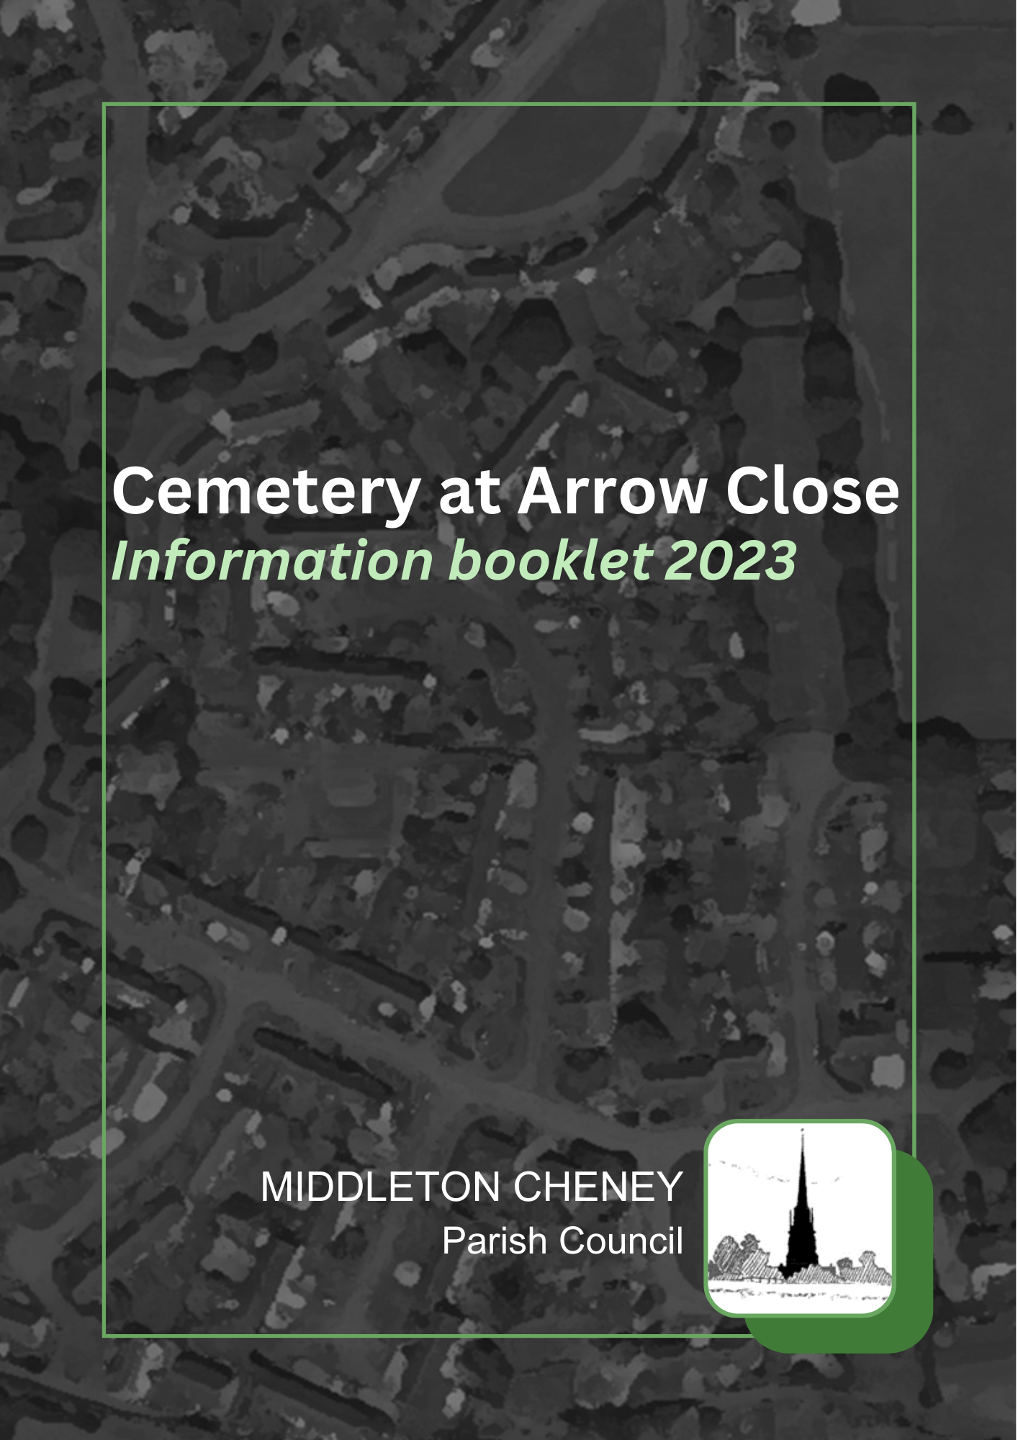
23/211 Cemetery handbook
To approve an updated and comprehensive regulations handbook for the cemetery.

Category: Regulations | Status: Draft
Responsible: Amenities/Clerk | Adoption minute ref: 23/211
Applicable to: Council | Adoption date:
Version: 1 | Next review: 08/2024

1.0 | General Information and Contact | 2
2.0 | Site Information | 2
3.0 | The Burial Process | 3
4.0 | Burial Plots | 5
5.0 | Memorials | 5
6.0 | Tributes | 6
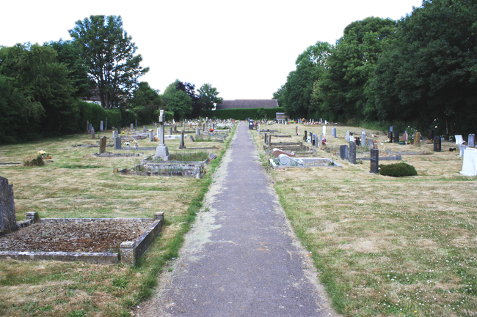
1. General Information
The Cemetery at Arrow Close has been an asset of Middleton Cheney Parish Council since 1923 and has provided a burial place for the residents of Middleton Cheney.
The Council is responsible for the management and maintenance of the Cemetery. We are committed to
improving the Cemetery and ensuring that it is a well-maintained and suitable resting place for loved ones.
1.1 General Enquiries
In the first instance, all enquiries should be made to Middleton Cheney Parish Council at the Parish Meeting Rooms, Main Road, Middleton Cheney, OX17 2LR, Tel 01295 713500.
Detailed plans and registers are kept in the Council office and information may be sought during office opening hours (please check the website for latest update of office hours).
1.2 Change of Address
It is very helpful when trying to contact the owner of plots/memorials that current addresses are available to the Council. If you change address, please advise the Council without delay.
1.3 Service Standards
The Council would value any comments you may have which could assist us to improve our service in the future.
1.4 Currency of information
All information within this document is correct at the time of printing. Changing legislation and circumstances may, however, cause future revisions to be made and these will be binding on all Deed holders.
2. Cemetery at Arrow Close
Site Information
2.1 Location
The cemetery is located at Arrow Close, Middleotn Cheney, OX17 2QJ
2.2 Opening Times
The cemetery is open to the public daily from dawn to dusk, with access through the main gates. The Council reserves the right to close the grounds and limit entry at any time.
2.3 Toilets
There are no toilet facilities at the Cemetery.
2.4 Dogs
Dogs MUST be kept on a lead and under control all times and owners are required to clear up after their dogs.
2.5 Watering
Water points are provided for visitors use. This water is unsuitable for drinking. The addition of pesticides
or insecticides to the water, or their use within the cemetery, is forbidden. Please also note that at certain times water supplies may be turned off to avoid freezing, this is normally between October and March but this may change depending on weather conditions.
2.6 Memorial Seats
The placement and style of seats is restricted and they may only be placed in certain locations in the cemetery. Please contact the Parish Council office to discuss options.
2.7 Security
The Council cannot accept responsibility for the security of any memorials, plants, flowers or other items placed on or around graves or memorial seats.
2.8 Children
Families with children are most welcome to visit the cemetery, but children MUST be kept under close supervision at all times.
2.9 Cemetery Gates
The cemetery is fitted with gates which are to be kept closed, we ask that you kindly close the gates as you leave.
2.10 Code of Conduct
Whilst visiting the cemetery please:
• be aware that funerals may be taking place within the cemetery
• treat other people in the cemetery with the utmost respect
• treat the cemetery, graves and memorials with respect
Whilst visiting the cemetery, please DO NOT:
• behave in a noisy, disorderly, or indecent manner, be intoxicated or drink alcohol, play any game, or use any abusive language, damage or destroy any tree, shrub, plant, headstone, memorial vase, plaque, seat or any other property within the cemetery
• ride a bicycle, motorbike or drive any motor vehicle other than those authorised by the Council or which is attending funerals
• obstruct any officer or any other person employed by the Council in the execution of their duties.
3. The Burial Process
3.1 Exclusive Right of Burial
An Exclusive Right of Burial (known as the Deed) MUST be purchased for a period of 75 years, at the time of submitting a notice for an interment. Burial spaces may be purchased either by residents or non-residents of Middleton Cheney, but please note that non-residents of Middleton Cheney will be subject to higher charges.
After the 75 year period the Exclusive Right of Burial may be renewed by the then owner of the right, for which a renewal fee will be payable and the new grant will be subject to the burial regulations then in place. The council will buy back any unused deeds at purchase price only.
For the purposes of this document, “Resident of Middleton Cheney” is defined as a person living in the civil parish of Middleton Cheney at the time of death, or a person who has lived in the civil parish of Middleton within the last five years.
There may be other circumstances in which a person might be deemed a resident of Middleton Cheney, but these are exceptional and each such application in this respect will be considered on its merits by the Parish Council.
The selection of grave spaces shall be determined by the Council which will, where possible, take into consideration the purchasers’ wishes.
3.2 Interments
Prior booking is required for every interment and this MUST be confirmed in writing on the Notice of Interment. A Notice of Interment MUST be given using the Council’s printed form and must be completed in full.
Responsibility for any errors or omissions rests with the person submitting the Notice. The Notice of Interment must be received by the Council at least three clear working days before the date of interment, unless for religious reasons and agreed with the Middleton Cheney Parish Council office. All charges and fees connected with the interment shall accompany the Notice of Interment and cheques should be made payable to “Middleton Cheney Parish Council”.
Failure to complete the Notice of Interment correctly or within the time specified may lead to a delay in interment and an increase in fees payable. Please note, for burial interments it may be necessary to temporarily store soil on adjoining graves.
3.3 Certificate for Burial or Cremation
The Certificate for Burial or Cremation, issued by the Registrar of Births and Deaths, MUST accompany the burial cortège and will be inspected at the cemetery upon arrival. Burials and cremations cannot take place without such certificates.
3.4 Existing Plot
Where the interment involves re-opening an existing plot, it will be necessary for the person giving notice to produce the Exclusive Right of Burial. Where the name on the Deed differs from the name of the person giving notice, proof of ownership will be required. Contact Middleton Cheney Parish Council office for advice and help regarding this subject.
The removal of any headstone, vase or table from a purchased plot to permit the interment shall be carried out to the order of and at the risk and expense of the person requesting the burial. This MUST be carried out in good and sufficient time for the grave to be opened.
The memorial and its foundations should be removed from the cemetery in its entirety during this time.
Headstones, vases or tablets removed to permit grave re-opening shall be replaced by a competent stone mason, and at the risk and expense of the Deed owner 9 months after the interment has taken place.
3.5 Plot care in advance of burial
In the event of poor ground conditions (e.g. flooding or subsidence), it may be necessary in the interests of health and safety to delay the interment into a plot until after the funeral cortège have left the cemetery. Should this be the case, every effort will be made to notify the Funeral Directors in advance but, if advance notice is not possible, notification will be given to the funeral cortège on its arrival at the cemetery.
3.6 Plot care immediately following burial
Back-filling of plot will not normally begin until funeral cortège are making their way out of the cemetery. Plots are then left slightly mounded to allow for settlement, and flowers delivered at the time of the burial will be carefully placed on the plot upon completion of back-filling. No memorials may be placed upon the plot within 9 months unless prior written agreement is received from the Council (this does not include the interment of ashes).
3.7 Lost Exclusive Right of Burial
Where an Exclusive Right of Burial (Deed) has been mislaid, it will be necessary for the person giving notice of the interment to provide proof of their identity and, if that person is not the Deed owner, to provide a letter of authorisation from the Deed owner.
Where the Deed owner is the deceased, authority for the interment is presumed by Section 10(6) of the Local Authorities Cemeteries Order 1977. In such cases, the next-of-kin and other close relatives are advised to agree who should take the assignment (or transfer) of the Exclusive Right of Burial. Contact the Council office for advice and help regarding this subject.
3.8 Hours of Interment
Monday to Friday: 09:00 to 14:30
Please be aware that, due to proximity of the cemetery to the secondary school entrance, it is recommended to avoid burials after 14:30.
Weekends/Bank Holidays: by special arrangement only immediate burials are allowed only on the grounds of religion or public health.
3.9 Religious Arrangements or Arrangements with the Minister
One section in the cemetery is un-consecrated. Those persons having charge of the funeral and
requiring their site to be blessed or consecrated are responsible for making the necessary arrangements.
3.10 Funeral Cortèges
Whilst in the cemetery, all funeral cortèges shall be subject to the direction of the Funeral Director. Musicians accompanying a funeral are welcome; however, to ensure disruption is not caused to other visitors, prior consent of the Council will need to be obtained.
3.11 Scattering of Ashes
Loose scattering of ashes is not permitted anywhere in the cemetery.
4. Plots
4.1 Burial Plots
The standard burial plot is 750mm (30”) wide and can be dug to either a single or double depth. A standard burial plot can also accommodate up to 6 ashes caskets.
The standard cremation plot is 450mm (18”) x 450mm (18”) and can be dug to either a single or double depth.
5. Memorials
5.1 Permission to install memorials
Only qualified Memorial masons are permitted to carry out the installation and/or removal of headstones within the cemetery.
5.2.a Burial Plots
All headstones must have maximum dimensions which should not exceed 2ft 6” (30”) in height and 2ft (24”) in breadth (3” thickness), with a base not exceeding 2ft 6 (30”) x 1ft 3” (15”) x 3”.
The plinth for the headstone may be placed, to accommodate no more than two flower holders, in front of the headstone if desired.
As long as these parameters are complied with, the design of the headstone can be tailored to personal requirements (please see paragraph 5.3 Memorial Approval). Planting outside of this area is NOT permitted (please see paragraph 6.1 Planting of plots—burial and cremation).
5.2.b Cremation Plots
Plots for ashes can have a maximum dimension of 450mm (18”) x 450mm (18”), with a maximum height of 100mm (4”). Memorials must be laid flat (tablet or desk style only). Planting outside of this area is NOT permitted (please see paragraph 6.1 Planting of plots—burial and cremation).
5.3 Memorial Approval
No memorial shall be erected anywhere within the cemetery except over a plot for which the Exclusive Right of Burial has been granted.
An application for permission to erect a memorial MUST be made using the Council’s Memorial Request Form, and contain a dimensioned drawing or illustration of the proposed memorial and a copy of the proposed inscription. This form should be submitted to the Council and be accompanied by the appropriate fee. No memorial shall be permitted unless written permission has first been obtained from the Council.
A copy of every additional inscription MUST be submitted to the Council for written consent before the work is commenced.
In giving approval for a memorial the Council will consider the safety and suitability of the design and whether it could cause offence.
5.4 Plot Aftercare and Memorials
Newly dug burial plots will be top-filled and seeded once the ground has settled (subject to weather and ground conditions). Memorials MUST NOT be placed on a burial plot for the first 9 months following an interment (this does not include the interment of ashes).
5.5 Memorial Masons
Memorial masons are able to give help and advice on the size and type of headstone. Once a suitable memorial has been chosen, the memorial mason will require the plot number and Deed number before details can be submitted to the Council for approval.
The memorial mason MUST contact the Council to arrange an appropriate time, giving one weeks’ notice for the memorial to be installed. Memorials must be placed with inscriptions to face East (School playing fields).
5.6 Additional Inscriptions
Additional inscriptions to memorials may be arranged by contacting a memorial mason, who will submit the application to The Council for approval. The memorial mason will require the plot number and the
Deed number before they can submit the application.
5.7 Kerbing/edging
Kerbing/edging is NOT allowed to be erected around any plots within the cemetery, this includes wooden edging, plastic edging, metal or concrete edging. The Council reserve the right to remove any structures created around plots without notice.
5.8 Maintenance of Memorials
The Deed owner is responsible for ensuring that the memorial is kept in a good state of repair and shall also be responsible for arranging the safe removal of the memorial to give access for re-opening of the plot should the need arise.
If the Council has to repair or make safe any memorial, for whatever reason including but not limited to lack of maintenance, inadequate installation or vandalism, it reserves the right to recover any costs incurred from the Deed owner.
5.9 Removal of Memorials
It may be necessary for The Council to give permission to temporarily remove a memorial to allow
excavations of an adjacent plot. The Council will endeavour to contact the Deed owner before such work commences but, if this proves impossible, the work will be authorised without advice to the Deed owner.
The costs in such circumstances will be borne by The Council.
6. Tributes – Floral and other
6.1 Planting of plots (burial and cremation)
Planting on or around plots is NOT permitted. The planting of trees and large shrubs is forbidden, and planting at the rear of headstones or to any side of cremation plots is not permitted due to its impact on neighbouring plots.
6.2 Vases and other Plant Containers
Vases and plant containers may be placed on individual plot. Due to health and safety considerations, such containers MUST NOT be of breakable materials. In this context, “breakable materials” are construed as glass, china, ceramic, terracotta etc. When assessing the potential breakability of items, The Council will always take a more cautious approach.
Any containers etc construed as being “breakable” WILL be removed by staff and held at the Parish Council office. The Deed owner will be notified of its removal, and if the item has not been collected after a period of three months, it will (as appropriate) either be donated to a charity or destroyed.
In implementing this policy, The Council will not be held responsible for any loss or damage to items removed.
Other items that could cause problems for site maintenance such as stones, gravel or shells (which could get caught in or projected by mowing machinery) are NOT permitted and will be removed.
6.3 Tributes – Floral
Floral tributes left at the time of the funeral will be removed by staff after 21 days. The Council cannot be held responsible for the safety and upkeep of funeral floral tributes and items left at the plot.
Visitors are requested to remove any wreaths or flowers placed on a plot as soon as they become wilted, otherwise they will be removed by staff.
Following special occasions, floral tributes will be removed as follows:
Christmas—8 weeks after Christmas
Mothers’ day—4 weeks after Mothers’ Day
Easter—4 weeks after Easter
Fathers’ Day—4 weeks after Fathers’ Day
6.4 Tributes – Other
Items which may be considered as offensive or disruptive (wind chimes/lights for example) will be
removed by the staff.
Solar and battery operated lights are not permitted.
The Deed owner will be notified of its removal, and if the item has not been collected from the Council office, after a period of three months, it will (as appropriate) either be donated to a charity or destroyed.
In implementing this policy, the Council will not be held responsible for any loss or damage to items removed.
Version | Author | Date | Changes | Status | Minute ref
1.0 | P Davis | 15/08/2023 |  | Draft | 23/211

23/217 PMR external regeneration update

As a Council, we have identified the area outside the Parish Council building is currently in need of some regeneration and could ideally be put to much better use. This document is intended to provide some inspiration to help establish a plan to do that.
Our Offices should be a welcoming place for residents to visit and ideally the “grounds” could be used to provide more of an enjoyable community space.
There are two separate things to consider – the building and the “grounds”. Also the removal of the cemetery shed and large plastic shed are involved in this potential project. All are considered below in short, medium and long term phases.
Short Term goals
Purchase and install storage container for PC grounds.
Remove cemetery sheds.
General simple to achieve grounds/building improvements

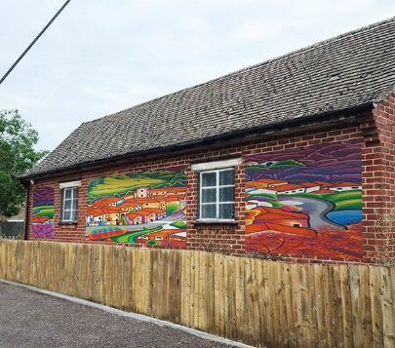
Building
Replace/repair warped MCPC sign by front door
Remove dated cigarette bin, replace with small sand bucket
Repair window
Paint/clean window frames
Paint plastered exterior walls
Brighten large wall spaces with artwork/murals

Grounds/cemetery
Remove cemetery shed and large insecure plastic shed
Remove old dog waste bins/signage/rubbish in the PC grounds
Remove remaining weeds and spray the gravelled areas to prevent return
Install secure storage container in PC grounds
Add trellis / planting to “soften” the container and make more pleasing to the eye
Add couple of planters by the front door / corners of the building with easy to maintain planting (suggest evergreen shrub with space around for bulbs/planting)

Requirements/labour/cost
Audit of what is stored in the cemetery sheds
Purchase of secure storage container for PC grounds
Skip hire for removal of cemetery shed and possibly large plastic shed, old signage/rubbish in the PC grounds and anything appropriate that could be removed from inside the building. Possibly Cllrs to volunteer, or hire someone to dismantle the sheds once audit is done and anything pertinent removed
Remove remaining weeds in PC grounds and spray
Hire tradesperson for repair/painting of windows
Purchase planters/trellis/planting
Potential community involvement
Approach the community (schools, Salmon’s House, art group etc.) to provide village themed murals to be
painted on boards and fixed to larger blank areas of the building exterior. There could be a grand “mural unveiling”!
Ask local businesses/residents (there are several who
like to upcycle old pallets etc) to make/provide a couple
of planters for outside the building – with a small sign to thank them/promote their work.

Medium Term Goals
Further Grounds improvement to enhance the space, involve and be of benefit to the community
Grounds
Seating area
Raised beds/planters on the gravelled area with easy to maintain planting, perhaps a small community herb garden.
Wild turf area behind the building (next to fire door)
Install insect hotels, bat boxes, bird feeders with information about what they are / who they attract
Repaint information board
Requirements/cost labour
All these things could easily be bought, but it would be much better
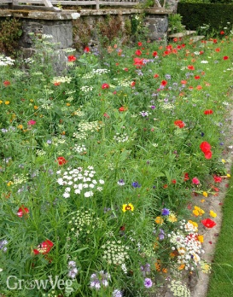
to engage the community in making the PC area more of a “hub” of the village.
Purchase of planting and wildflower seed/turf
Workshop hosts
Repainting of sign
Information signs about the insect hotels/planting/pollinators etc.

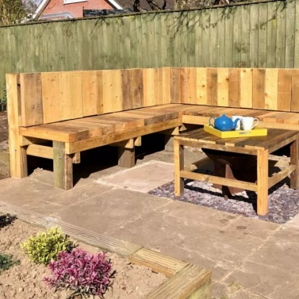
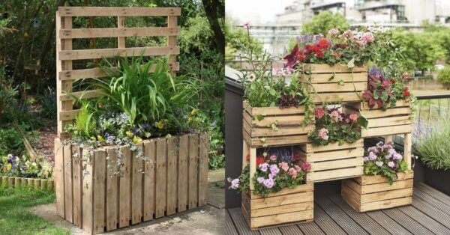
Potential Community Involvement
Building a seating area/raised beds/planting up appropriately
Workshops to make insect hotels, bat boxes, raised bed
A small “experiment” to see whether any residents would make use of the herbs available and if anyone is prepared to help take care of them.
Signage thanking those who made it happen.
Long Term – Dependent on how the previous two phases were received
Create a space which the community want to visit, want to be part of, care about and feel engaged with

Grounds
Removal of gravel and weed membrane
Replace membrane and reinstate gravel, or lay to grass to make more of an enjoyable “garden space” for residents to enjoy.
Add more raised beds, potted fruit trees/bushes

Potential Community Involvement
Helping to maintain the planting
Making use of the herbs/fruit trees
Hosting outdoor workshops
Enjoying the space!
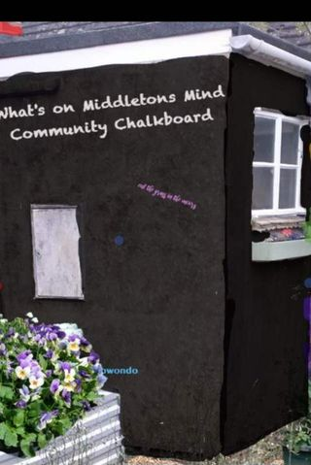
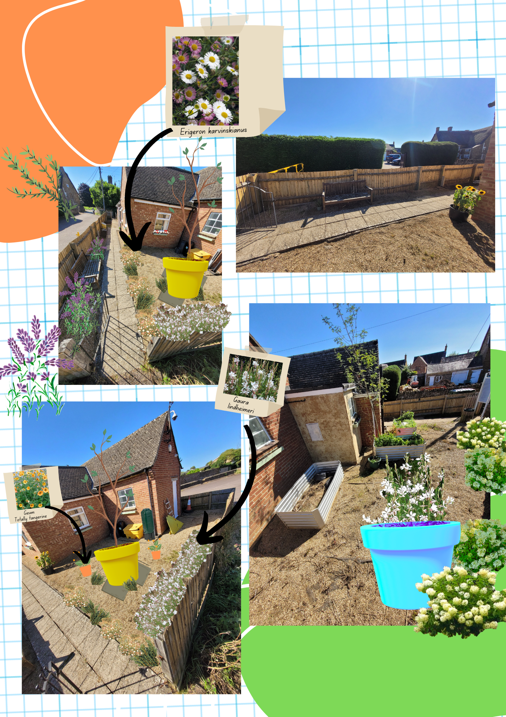
Meet ‘The Biggie’ - The New Big Plant Pot on the scene!
‘The Biggie’ - A classic flower pot design with a new, contemporary, matt finish, in a range of 8 pigment rich tones. This extra large plant pot is sophisticated and elegant, classic and timeless. Designed and manufactured in the UK, with fast delivery,
easy communication and no minimum order quantity. ‘The Biggie’ is a stylish, space-defining statement.
Using a rotational moulding process, ‘The Biggie’ is made of recyclable, linear medium-density polyethylene. This technique gives an incredibly durable finish and allows us to permeate the colour right through the planter giving a colourfast result.
At 421 Litres
‘The Biggie’ is ideal for trees especially Olive trees, flowers, grasses and is the perfect height for a herb garden in a residential or public setting.
RRP £299
Wholesale prices available upon request.
Shipping Information:
We currently have a next day to 3 Week delivery time depending on colour and quantity. Our deliveries are palletised and we can stack upto 6 pots on one pallet.
Our shipping rate for England and Wales is £35. For Scotland it's £55
Colours: Additional colours available with minimum order quantities. Contact us for more information.
Product Dimensions;
Width top 1000mm
Width bottom 572 mm
Height 910mm
421 litres

Product specifications;
Extremely durable.
Medium Density Polyethylene
Impact resistant.
Rust resistant
Crack/shatter/Frost proof.
UV Stabilised.
Lightweight for easy placement.
Stackable
Matte finish
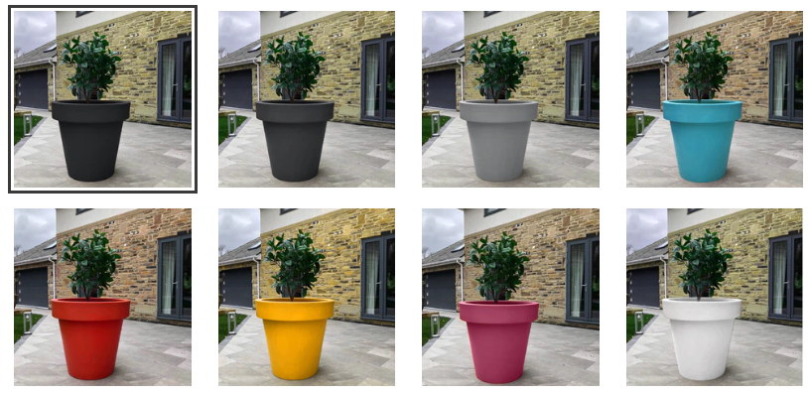
PLEASE PAY CLOSE ATTENTION TO THE DIMENSIONS OF OUR POT. BE SURE IT FITS IN THE SPACE YOU WANT TO PLACE IT. WE HAVE A MINIMUM COLLECTION CHARGE OF £150. THIS IS DUE TO THE SIZE AND THE HIGH COST OF TRANSPORT.

23/220
Authorisation of Payments

Aug-23
Month 5 - Tax Year 2023-24
29/06/2023 | PD Expenses | BACS | B&Q | 21.11 | 16.89 | 38.00 |  | Compost, plants
13/07/2023 |  | Debit card | Amazon | 2.08 | 0.42 | 2.50 |  | HDMI cable
17/08/2023 |  | Debit card | Tesco | 27.17 | 5.43 | 32.60 |  | Butt, Cleaning products
25/07/2023 | INV-0418 | BACS | B R Cherry | 4000.00 | 0.00 | 4000.00 |  | Permissive Bridleway
16/08/2023 | 5341 | BACS | Best area magazines | 450.00 | 0.00 | 450.00 |  | Cheney chatter printing
01/08/2023 | INV1110922244 | BACS | Go2 (red office) | 29.50 | 5.90 | 35.40 |  | Refuse sacks
21/07/2023 | INV-3220 | BACS | NCALC | 84.00 | 16.80 | 100.80 |  | PD NT attendance Civility and Respect
27/07/2023 | 6772 | BACS | Shield | 147.33 | 29.47 | 176.80 | 4511 | Dog waste bin collection
31/07/2023 | 25518 | BACS | Slade estate services | 3512.47 | 702.49 | 4214.96 | 4540-6 | Grass cutting 1st - 31st May
 |  | DD | Hiscox | 310.08 | 0.00 | 310.08 |  | Insurance
 |  | DD | Nest | 136.39 | 0.00 | 136.39 | 4020 | Pensions
24/07/2023 | 22265425 | DD | O2 | 22.50 | 4.50 | 27.00 | 4553 | Mobile contracts
17/08/2023 | 834379 |  | Onecom | 76.36 | 15.27 | 91.63 |  | Broadband
17/07/2023 | 808663 | DD | Onecom | 76.36 | 15.27 | 91.63 | 4460 | Broadband
 |  | DD | Rydal | 39.08 | 7.82 | 46.90 | 4552 | Remote support
15/08/2023 | 81137 | DD | Rydal | 76.78 | 15.36 | 92.14 | 4553 | CCTV mobile phone
07/08/2023 |  | DD | Seimens | 225.00 | 45.00 | 270.00 |  | Printer lease Qtr
31/07/2023 | . | DD | Seimens | 103.00 | 20.60 | 123.60 | 4550 | CCTV lease
31/07/2023 | 471371 | DD | SGW Payroll | 31.50 | 6.30 | 37.80 | 4022 | Payroll
09/07/2023 | 301170 | DD | Tower leasing | 157.00 | 31.40 | 188.40 | 4550 | CCTV system, tilt zoom camera, pole
30/04/2023 | August | BACS | Richard Jerrams Coughtrey |  |  |  | 4000 | Monthly salary
30/04/2023 | August | BACS | Debbie Burdett |  |  |  | 4000 | Monthly salary
30/06/2023 | August | BACS | Pip Davis |  |  |  | 4000 | ≤Monthly salary, TBC
to 13/04/2023 | mid-July-mid-August | BACS | Pip Davis |  |  |  | 4000 | ≤10% overtime, TBC
 |  |  |  |  | Total | 10,677.07 | & Salaries
 |  |  |  |  |  | Bank Balances as at 16/08/2023
 |  |  |  |  |  | Community Account |  | 62.2
 |  |  |  |  |  | Business Premium Account 360 |  | 301,466.55
 |  |  |  |  |  | Business Premium Account 259 |  | 77.443.01

